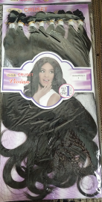

BalinA-8pcs-TG- 111

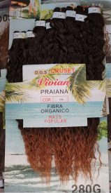

SUPER MAHI PRAIANA-8PCS(280克)

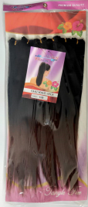

Yaki wave-6pcs

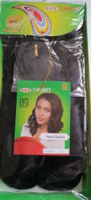

NEW CLUDIA

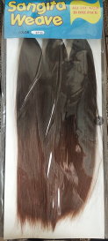

SINGETA -3PCS

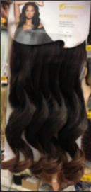

DANELA-11-18"-1PCS

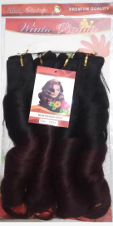

MAHI BRAND-4PCS

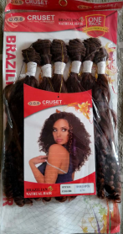

VIYAN LI-6PCS

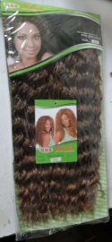

MAGIC-FOREVER

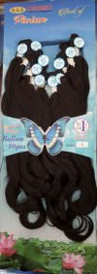

BalinA-10pcs

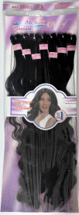

DANCING CURL-7PCS

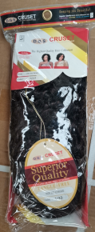

NEW HOLLYWOOD

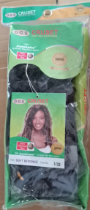

SOFT BEYONCE

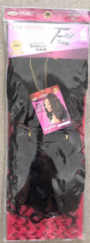

SALAFINE-3PCS

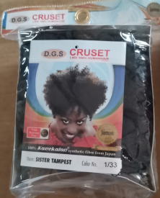

Sister

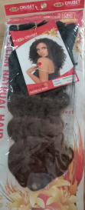

ZUOZUO-1PCS-200

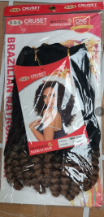

VIVI-111808SSSS

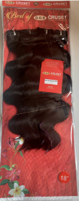

BEST BLINA BODY 18 inches

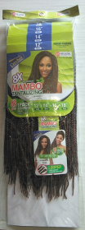

8X MAMVO -8PCS,12"+14"+16"+18”

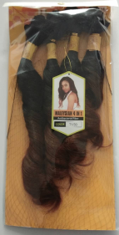

Malaysian 4in1 240G

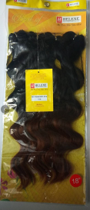

BEST BLINA BODY-4PCS-18 inches (240gr)

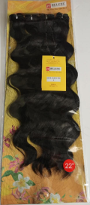

BEST BLINA BODY-4PCS-22 inches (240gr)

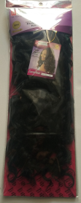

SARAFINE (100+100+26=226克

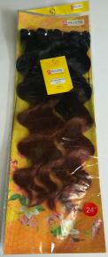

BEST BLINA BODY-4PCS-24"(240gr)

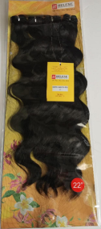

BEST BLINA BODY-4PCS-22"(240gr)

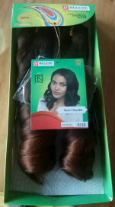

NEW Claudia (226克) (hard)

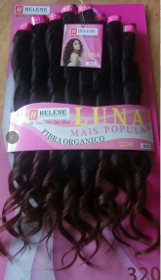

SUPER HELEN LUNA-8PCS

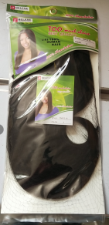

YAKI-100+126 = 226克

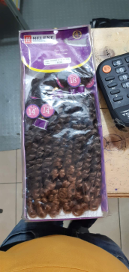

DURABLE14"16'18' -6PCS

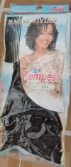

Tempest(2PCS-200克)

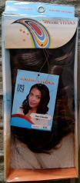

NEW Claudia(200克)

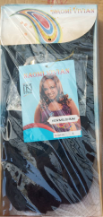

NEW MILIUMN SHORT

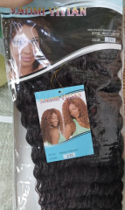

MAGIC-FOREVER

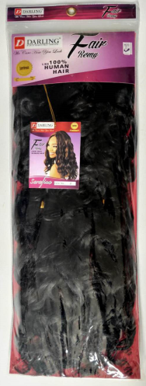

SARAFINA curl (100+100+26=226克)

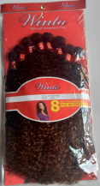

RAINBOW-8PCS 230g

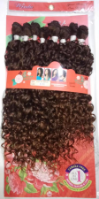

VIVI-16英寸8PCS

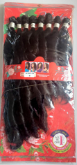

VIVI-8（220）

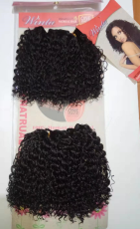

BALINA-S-BOHEMLANI-120

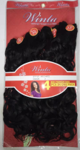

（49-3）-4pcs20"18"16"14"(240克)

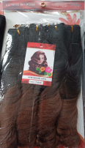

WOW BRAND-4PCS240

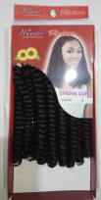

SPRING CURL-12”-3PCS

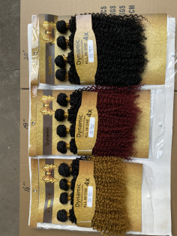

Dynamic kinky